



**Scaling Digital Twin Experiences 302  
Configurations and Content Storage with ThingWorx**

**Copyright © 2020 PTC Inc. and/or Its Subsidiary Companies. All Rights Reserved.**

User and training guides and related documentation from PTC Inc. and its subsidiary companies (collectively "PTC") are subject to the copyright laws of the United States and other countries and are provided under a license agreement that restricts copying, disclosure, and use of such documentation. PTC hereby grants to the licensed software user the right to make copies in printed form of this documentation if provided on software media, but only for internal/personal use and in accordance with the license agreement under which the applicable software is licensed. Any copy made shall include the PTC copyright notice and any other proprietary notice provided by PTC. Training materials may not be copied without the express written consent of PTC. This documentation may not be disclosed, transferred, modified, or reduced to any form, including electronic media, or transmitted or made publicly available by any means without the prior written consent of PTC and no authorization is granted to make copies for such purposes. Information described herein is furnished for general information only, is subject to change without notice, and should not be construed as a warranty or commitment by PTC. PTC assumes no responsibility or liability for any errors or inaccuracies that may appear in this document.

The software described in this document is provided under written license agreement, contains valuable trade secrets and proprietary information, and is protected by the copyright laws of the United States and other countries. It may not be copied or distributed in any form or medium, disclosed to third parties, or used in any manner not provided for in the software licenses agreement except with written prior approval from PTC.

UNAUTHORIZED USE OF SOFTWARE OR ITS DOCUMENTATION CAN RESULT IN CIVIL DAMAGES AND CRIMINAL PROSECUTION.

PTC regards software piracy as the crime it is, and we view offenders accordingly. We do not tolerate the piracy of PTC software products, and we pursue (both civilly and criminally) those who do so using all legal means available, including public and private surveillance resources. As part of these efforts, PTC uses data monitoring and scouring technologies to obtain and transmit data on users of illegal copies of our software. This data collection is not performed on users of legally licensed software from PTC and its authorized distributors. If you are using an illegal copy of our software and do not consent to the collection and transmission of such data (including to the United States), cease using the illegal version, and contact PTC to obtain a legally licensed copy.

**Important Copyright, Trademark, Patent, and Licensing Information:** See the About Box, or copyright notice, of your PTC software.

**UNITED STATES GOVERNMENT RIGHTS**

PTC software products and software documentation are “commercial items” as that term is defined at 48 C.F.

1. 2.101. Pursuant to Federal Acquisition Regulation (FAR) 12.212 (a)-(b) (Computer Software) (MAY 2014) for civilian agencies or the Defense Federal Acquisition Regulation Supplement (DFARS) at 227.7202-1(a) (Policy) and 227.7202-3 (a) (Rights in commercial computer software or commercial computer software documentation) (FEB 2014) for the Department of Defense, PTC software products and software documentation are provided to the U.S. Government under the PTC commercial license agreement. Use, duplication or disclosure by the U.S. Government is subject solely to the terms and conditions set forth in the applicable PTC software license agreement.

PTC Inc., 121 Seaport Blvd, Boston, MA 02210 USA

**Intro**

You saw in the previous tutorial that you can create AR experiences that have configuration data stored in ThingWorx in tandem with the IRS. The same data that was stored in the IRS can also be stored completely in ThingWorx, including the PVZ of your model! This tutorial will teach you how to use ThingWorx data storage for creating configured Vuforia Studio experiences.

**302.1 Creating a File Repository in ThingWorx**

Before anything can be edited in Vuforia Studio, a file repository needs to be created in ThingWorx to store PVZ models.

1. In your ThingWorx instance, create a new Thing. Populate the **General Information** tabwith the following information and click **Save**:
   1. **Name**: FileRepo
   2. **Project**: Your project name
   3. **Base Thing Template**: FileRepository

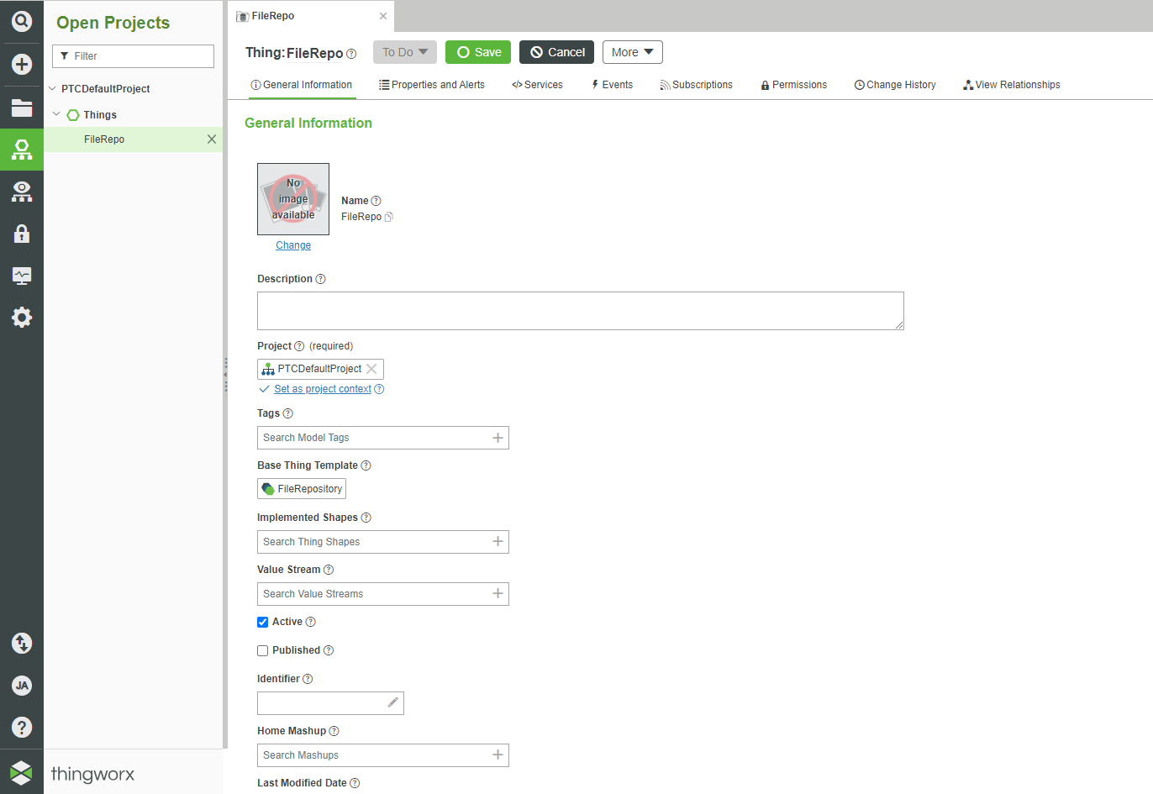

1. In the ThingWorx sidebar, open the **Manage** tab. You will see FileRepo listed under **Repositories**.

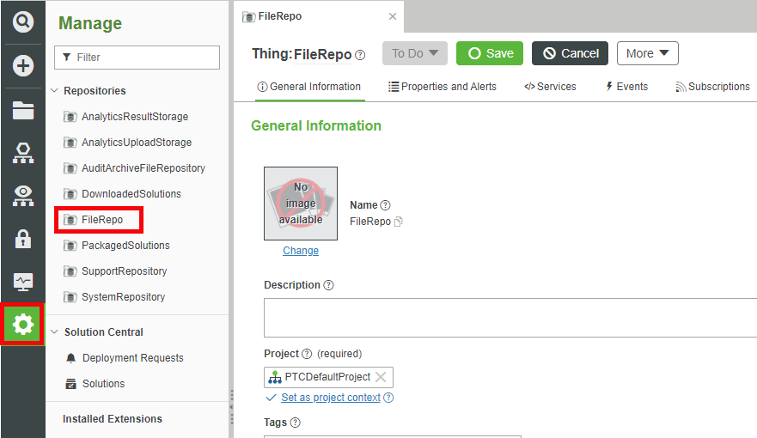

1. Open FileRepo and click on the **…** in the **Actions** column. Select **Upload** to upload the **Upload File** window.

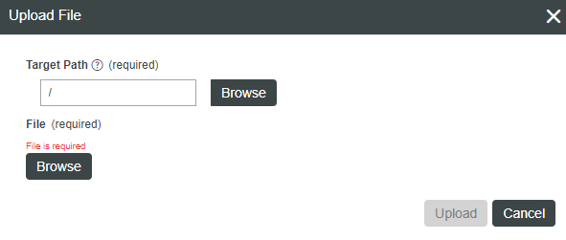

1. Find the ScalingDigitalTwinExperiences202 folder where you have your Vuforia Studio projects stored. Inside the project folder, follow the path of **src > phone > resources > Uploaded** to locate the PVZ and metadata JSON files for both quadcopter models that you have been using.

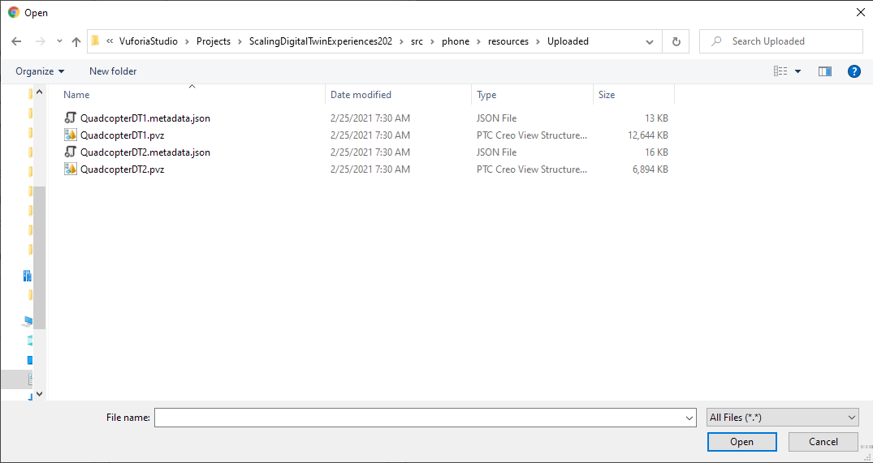

1. One by one, select each file and click **Open**. Once it is added to the **Upload File** window, click **Upload** to upload the file to the repository.
2. Your repository should have PVZ and JSON files for both quadcopter models when complete.

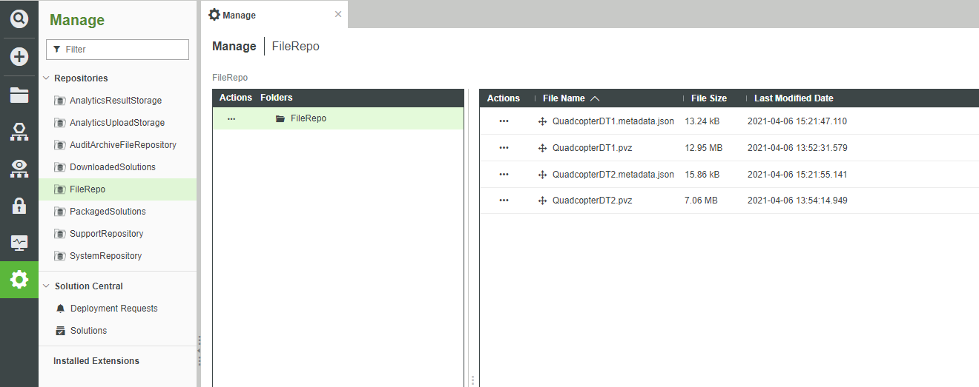

**302.2 Edit Your Thing Template and Things**

Since they will not be stored in the IRS anymore, the properties for each quadcopter will need to be added to the Quadcopter Template Thing Template. Adding those properties to the Thing Template will add them to each Thing that is created from that template. Once the Thing Template is updated, each Quadcopter Thing will need to give values to their new properties.

1. Open your Quadcopter Template Thing Template in ThingWorx.
2. Navigate to the **Properties and Alerts** tab.
3. Add two new properties to the template: color and modelPVZ. color will act the same as before, it will be a string type that is added into Vuforia Studio and used to determine the color of the quadcopter shell. modelPVZ will be a hyperlink type with an URL that connects to the model storage in the repository that you created in the last section.
   1. color
      1. **Name**: color
      2. **Base Type**: STRING
      3. **Persistent**: ON
   2. modelPVZ
      1. **Name**: modelPVZ
      2. **Base Type**: HYPERLINK
      3. **Persistent**: ON

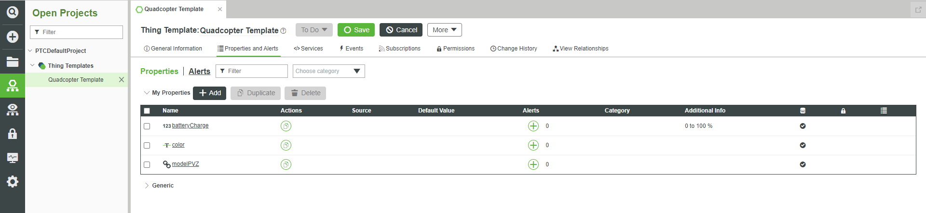

1. Click **Save** to save your new properties for the Quadcopter Template.
2. Browse to your Quadcopter1 Thing that you created in the last tutorial. You should see that the color and modelPVZ properties have now been added to your Thing.

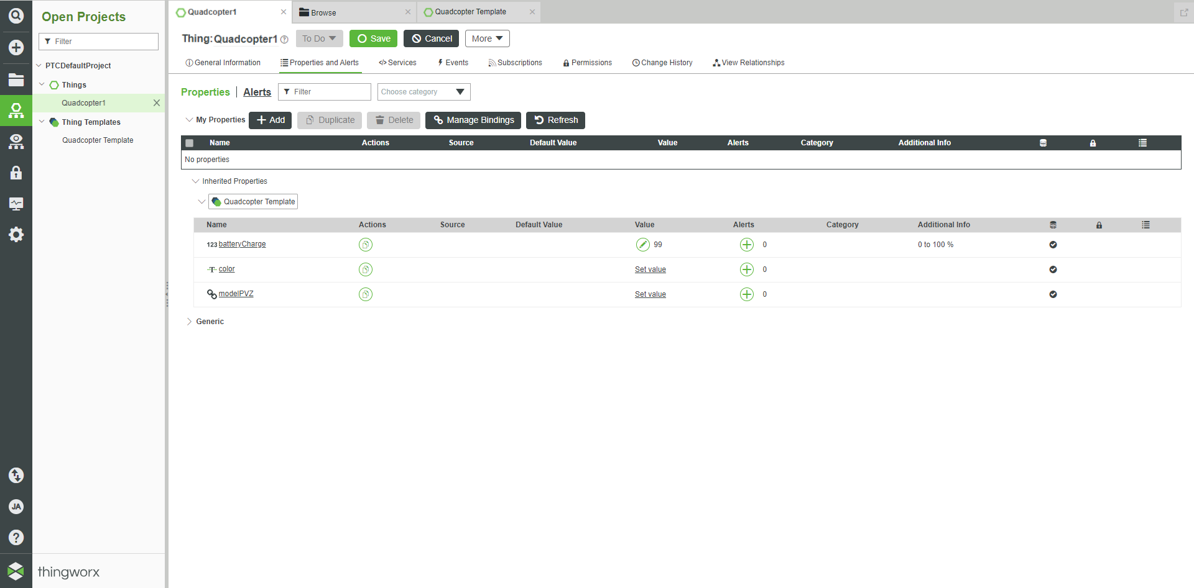

1. For the color property, set it to the one of the color values that was created in Studio. The value of the modelPVZ property needs to be set to the location inside ThingWorx that the PVZ files are stored in. The value of this property should follow this format: /Thingworx/FileRepositories/(YOUR REPOSITORY NAME)/(YOUR MODEL NAME). Any folders within folder will add another level to the path. In this case, set the URL to /Thingworx/FileRepositories/FileRepo/QuadcopterDT2.pvz

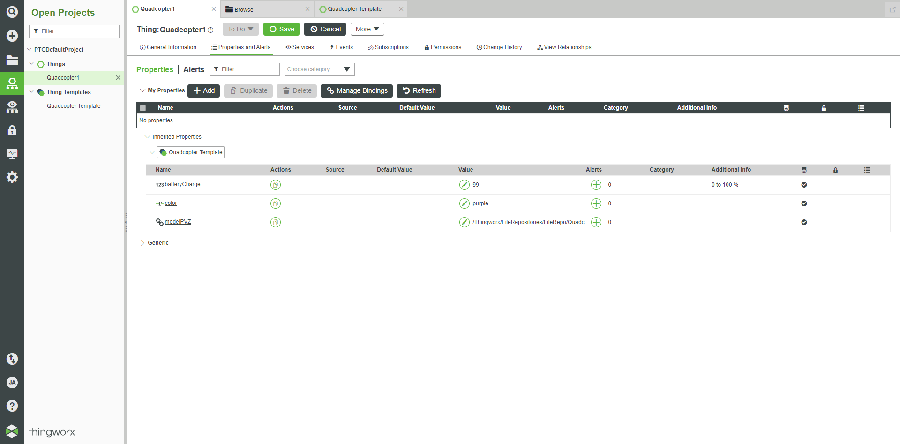

1. Repeat this process for the Quadcopter2 and Quadcopter3 Things so their properties are populated. This will complete all the edits that need to be made to your ThingWorx instance.

**302.3 Update Your Vuforia Studio Experience**

Now that your configuration data has been stored inside ThingWorx, your Vuforia Studio experience needs to be edited to accept these changes.

1. Open ScalingDigitalTwinExperiences202 in Vuforia Studio.
2. Remove all PVZ and JSON files under **Resources**. These will be loaded from ThingWorx now.
3. The newly created color and modelPVZ properties will need to be added to the experience for the dynamic Quadcopter entity. Click the **+** next to **External Data** to open the **Add External Data** window. Search for Quadcopter1 and add the color and modelPVZ properties to the experience. These will allow data from ThingWorx to be accessible inside Vuforia Studio.

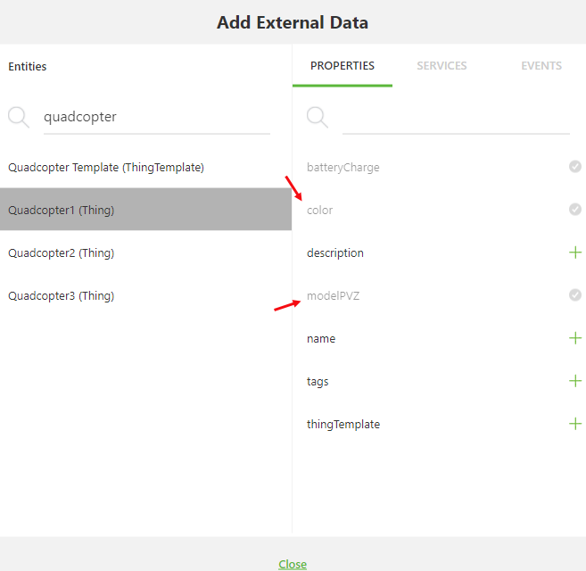

1. Bind the color property to the **color** application parameter. The value of this application parameter will now be set by the property value for color in ThingWorx.

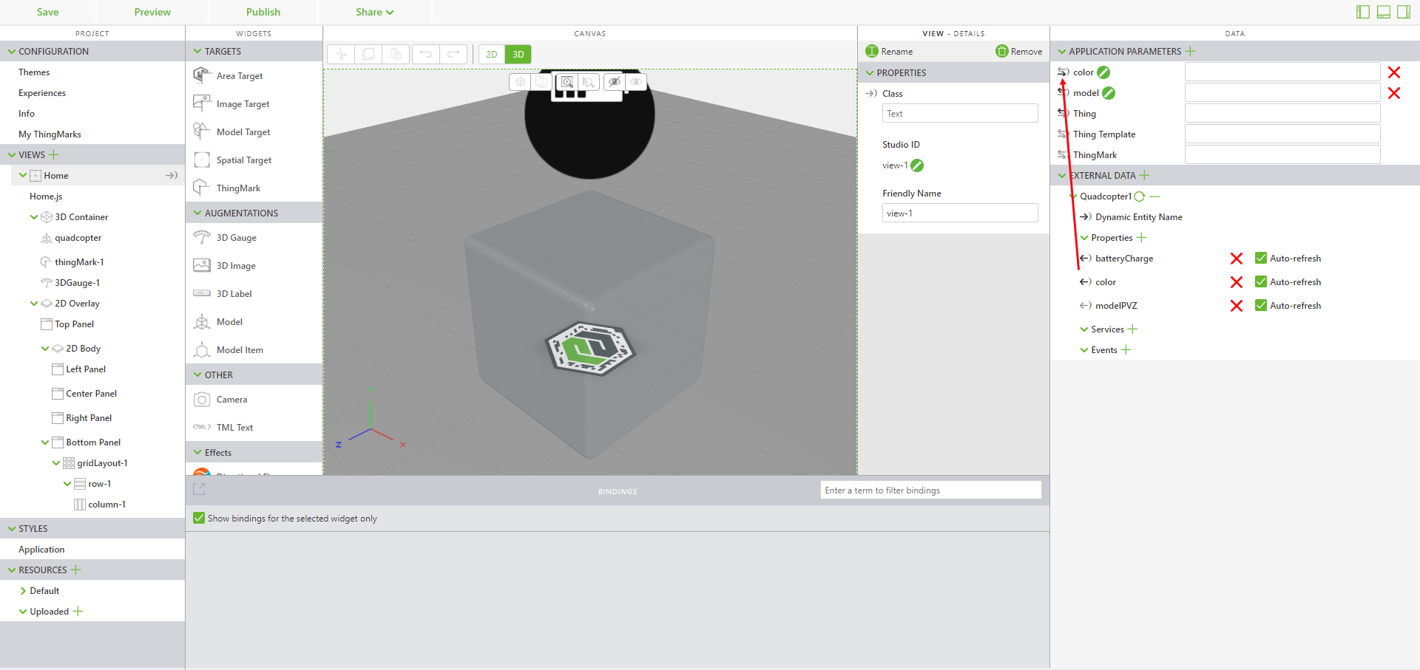

1. Bind the modelPVZ property of Quadcopter1 to the **Resource** property of the quadcopter model widget. Instead of using a model loaded into Vuforia Studio, the Resource property will set itself to be the file that is located at the URL that is the value of the modelPVZ property.

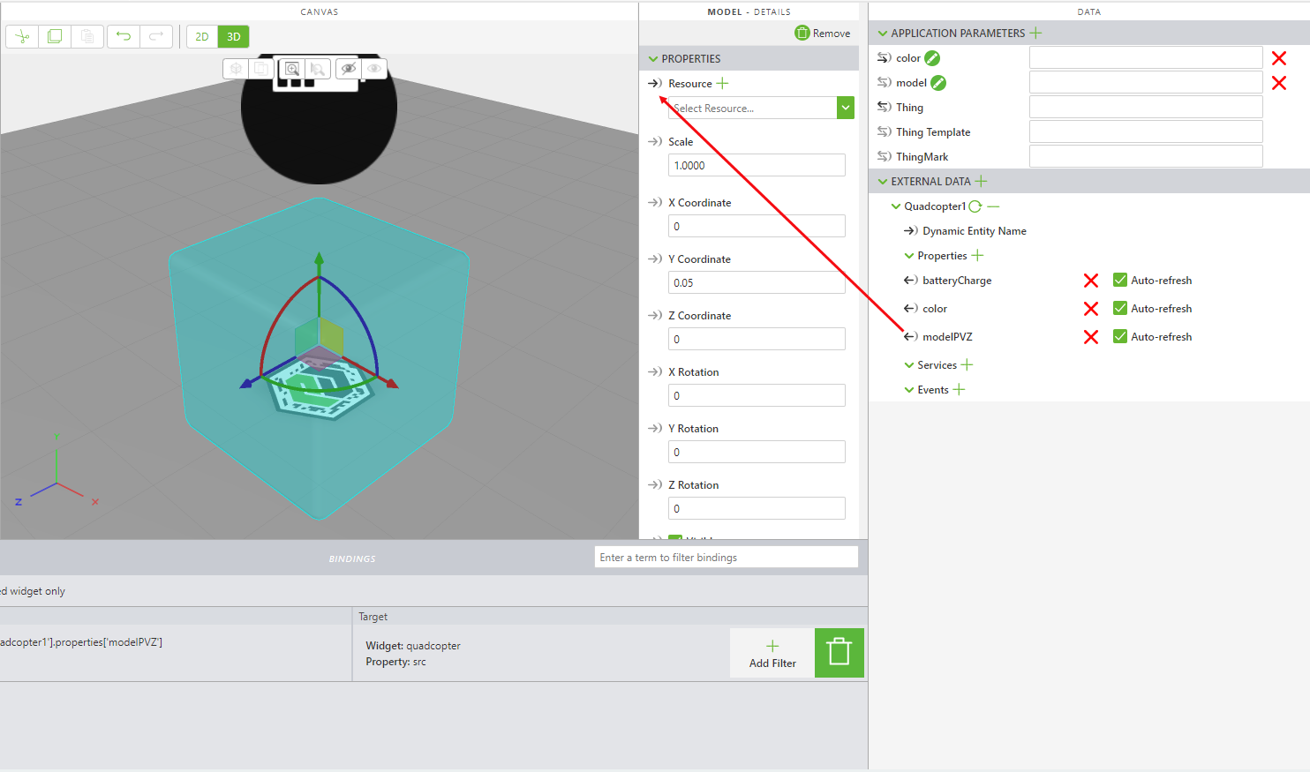

1. You may have noticed that the binding between the **model** application parameter and the **Resource** property of the quadcopter model widget was broken in the last step. The **model** application parameter is no longer needed since the model is being stored in ThingWorx, so you should remove it completely.
2. Your Vuforia Studio experience has now been updated to its proper state. Click **Publish** to publish your updated experience.
3. A Vuforia Studio project with the new changes added in this section named [ScalingDigitalTwinExperiences302](https://github.com/PTCInc/StudioExamples/tree/master/Scaling%20Digital%20Twin%20Experiences/Scaling%20Digital%20Twin%20Experiences%20200/ScalingDigitalTwinExperiences202) can be found in GitHub. **Note**: As with the last tutorial, this project is meant to be used as a reference material for the project file unless you have changed your template mapping.

**302.4 Delete IRS Mappings**

Since the color and model properties are now stored within ThingWorx, their mappings in the IRS need to be deleted. The only IRS mappings that should still exist for your configurations should be to the Things that they are associated with.

1. Open your CLI and change your directory if necessary, to the location of your batch files for this tutorial set.
2. Find the ID of the mappings that you created for mapping the color and model properties to the configurations that you have created. There should be 6 ID’s in total that were used for those property mappings. Use the line of code below in the CLI to remove those mappings from your experience. Substitute IDNUMBER with the ID of the mapping that you are deleting.

curl -u %uname%:%passwd% -k -H "X-Requested-With: XMLHttpRequest" -X DELETE %server%/ExperienceService/id-resolution/mappings/IDNUMBER

1. Your remaining mappings should be the following:
   1. urn:vuforia:vumark:YOURTHINGMARK => urn:curriculum:config:1
   2. urn:curriculum:config:1 => urn:curriculum:thing:Quadcopter1
   3. urn:curriculum:config:1 => urn:thingworx:template:curriculum
   4. urn:thingworx:template:curriculum => your experience
   5. urn:vuforia:vumark:YOURTHINGMARK => urn:curriculum:config:2
   6. urn:curriculum:config:2 => urn:curriculum:thing:Quadcopter2
   7. urn:curriculum:config:2 => urn:thingworx:template:curriculum
   8. urn:vuforia:vumark:YOURTHINGMARK => urn:curriculum:config:3
   9. urn:curriculum:config:3 => urn:curriculum:thing:Quadcopter3
   10. urn:curriculum:config:3 => urn:thingworx:template:curriculum
2. Validate your new mappings. Scan each of your ThingMarks. If the correct combinations of color, quadcopter model, and battery level appear with the correctly designated ThingMark, you have successfully completed this tutorial. Try changing the properties inside ThingWorx to see how they can be updated in real time.